**OSHW OLED Watch**

Jul 22, [2014](http://jared.geek.nz/2014/jul/2014) [electronics](http://jared.geek.nz/tags/electronics), [oled](http://jared.geek.nz/tags/oled), [oshw](http://jared.geek.nz/tags/oshw)

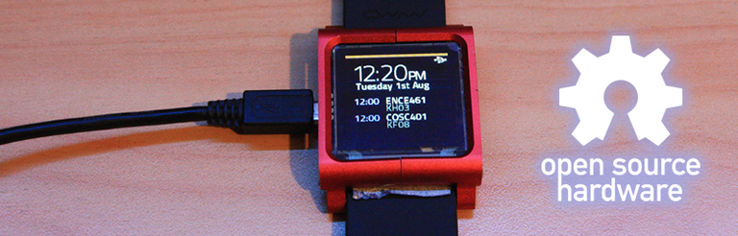

Previous Posts:

* [2014 Jul - OLED Watch Is Alive!](http://jared.geek.nz/2014/jul/oled-watch-is-alive)
* [2013 Oct - OLED Watch Rev 2](http://jared.geek.nz/2013/oct/oled-watch-rev-2)
* [2013 May - OLED Watch](http://jared.geek.nz/2013/may/oled-watch)

Over the last year or so I have been working on this project; a custom-built smartwatch! It is still very much a work in progress, and I have plans to build a new hardware platform in the future... Everything was built from the ground-up: the schematics, PCB, firmware, and PC software. The only third-party firmware I'm using is Microchip's USB stack.

If you haven't heard about this project, I highly recommend you check out the links to the right where I go into much more detail about problems I've run into and how I built the hardware.

The main difference between this project and most consumer smartwatches is that I designed it with hackability in mind, so that it can be built by hand by anyone who has some basic SMD tools, and of course it's completely open-source and free for modification!

You are welcome to try build this yourself, but I do plan on creating a Revision 3 in the future, fixing all the issues with this revision. So beware that there are bugs and errors in the schematic and PCB!!!

**Downloads**

The firmware is available on my github: [jorticus/zeitgeber-firmware](https://github.com/jorticus/zeitgeber-firmware)  
You will need the MPLAB-X IDE, the XC16 free compiler, and the Microchip Application Framework.

The schematics and PCBs were designed in Altium Designer, and are available here:  
Sources: [OLED-Watch-Rev2-Altium.zip](http://jared.geek.nz/oshw-oled-watch/files/OLED-Watch-Rev2-Altium.zip)  
Schematic: [OLED-Watch-Schematics.pdf](http://jared.geek.nz/oshw-oled-watch/files/OLED-Watch-Schematics.pdf)  
Gerbers: [OLED-Watch-Rev2-Gerbers.zip](http://jared.geek.nz/oshw-oled-watch/files/OLED-Watch-Rev2-Gerbers.zip)  
PCB: [OLED-Watch-PCB.pdf](http://jared.geek.nz/oshw-oled-watch/files/OLED-Watch-PCB.pdf)   
BOM: [OLED-Watch-BOM.xlsx](http://jared.geek.nz/oshw-oled-watch/files/OLED-Watch-BOM.xlsx)

You can also order 3x PCBs directly from OSHPark: [OLED Watch](https://oshpark.com/shared_projects/cXvq9TpQ)

[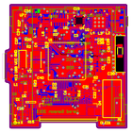](http://jared.geek.nz/oshw-oled-watch/images/pcb-screenshot.png)[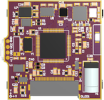](http://jared.geek.nz/oshw-oled-watch/images/pcb-3d.png)[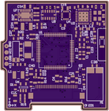](http://jared.geek.nz/oshw-oled-watch/images/pcb-top.png)[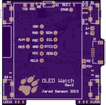](http://jared.geek.nz/oshw-oled-watch/images/pcb-bottom.png)

**Hardware Features**

My hardware consists of the following components:

* PIC24 CPU
* MMA7455 Accelerometer
* HMC5883L Magnetometer
* 128x128 Colour OLED Display
* 4x Buttons
* Peizo buzzer
* Vibrator motor
* USB charging & communications
* nRF8001 Bluetooth 4.0 LE Chip (untested)

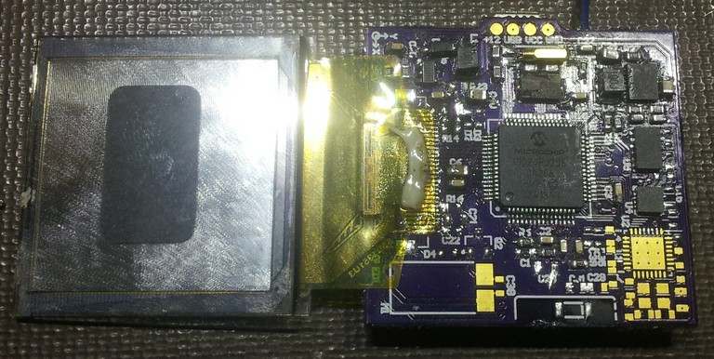

**Bill Of Materials**

The total cost of components is about $100, excluding the PCB and tools required. Most of the components can be purchased through Element14/Farnell and Sparkfun. I haven't included generic SMD 0603 resistors and capacitors, you should [buy a few packs](http://www.dx.com/s/smd+0603) from DealExtreme or Element14.

I also found a cheaper source for the OLED displays on [AliExpress](http://www.aliexpress.com/item/2pcs-1-5-inch-color-OLED-Display-screen-with-128x128-Resolution-SPI-Parallel-Interface-SSD1351-Controller/1461252182.html), and the buttons can be obtained from[DealExtreme](http://www.dx.com/p/td-15ea-tact-switches-50-piece-pack-122524).

NOTE: I haven't yet ordered the bluetooth nRF8001 chip, so the bluetooth circuitry has NOT been tested!

**Bugs**

As you can tell from my previous posts, my PCB had quite a few bugs. I've managed to fix or work around most of them luckily.

The biggest mistake I made was wiring the OLED connector in backwards! I was able to work around this by flipping the OLED, but it made it a lot harder to fit into the case. Originally I had intended that the OLED display would wrap around the PCB, sandwiching the battery between the display and the buttons with the buttons around the sides.

I also neglected to connect the OLED to the PIC's dedicated graphics output pins, which provide hardware-accelerated video output without the need for CPU intervention. So unfortunately I can't make use of this, so I'm just bit-banging the data out one of the ports. I can achieve an update rate of 33ms (excluding drawing things to the framebuffer) through this method.

**Bug Fixes**

Power Circuit:

* CE pin should be pulled low by default, to enable charging if battery is flat. FIX: R19 is located near a GND pad (C4). Re-orient and use thin wire to connect to GND.
* ISET2 should be pulled high, the OLED draws JUST more than 100mA. FIX: R26 is located near VCC (BTN/R24/R22). Re-orient and connect to VCC
* VDD should be set to 3.1V, not 2.5V, since the PIC requires a minimum of 3.1V for USB to function correctly. Change R18 to 121K 1% resistor.
* EPWR should be grounded with a 1Mohm resistor, or it won't power up.
* Resistor on ISET1 (R27) was set too low, battery would never charge. Change to 1Kohm.

OLED:

* Screen connector needs to be plugged in reverse. Make sure you get a connector with conductors on the bottom edge (or both edges).
* Power diode's footprint was too small. It's easy enough to bodge in.

**Case**

I was going to 3D print a case for the watch, but I stumbled across [the following product] on DealExtreme. It was originally ment to be used with an iPod Nano, but by pure luck the dimensions fit my PCB and screen almost perfectly! Unfortunately since the OLED is now on the wrong side of the PCB, I had to remove the back of the case with a bench grinder so that the PCB and battery would fit. You can see a closeup of how it all fits together below:

[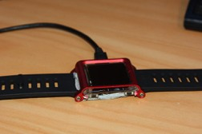](http://jared.geek.nz/oshw-oled-watch/images/IMG_4550.JPG)[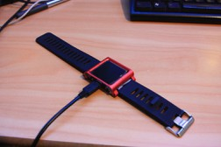](http://jared.geek.nz/oshw-oled-watch/images/IMG_4548.JPG)[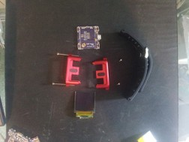](http://jared.geek.nz/oshw-oled-watch/images/IMG_20140105_111812.jpg)Case before modification

**Footnotes**



All design files and source code is released under the [OSHW License](http://freedomdefined.org/OSHW). ie. You may modify, distribute, make, and sell the design, as long as you provide attribution.